Dates | English |  | Year level/s |  | Teachers |  | Fortnight
 | Day 1 | Day 2 | Day 3 | Day 4 | Day 5 | Day 6 | Day 7 | Day 8
Reading | Learning Intention  We are learning to make predictions in texts  Success Criteria  I will be successful if I can search for and use information to confirm or refute predictions  Teaching Sequence  Guided Group  Lesson for each group: In the first 20 days develop norms for the guided groups on an anchor chart and complete a shared reading to practice those norms | Learning Intention  We are learning to make predictions in texts  Justify predictions using evidence  Success Criteria  I will be successful if I can:  - search for and use information to confirm or refute predictions  - Justify predictions using evidence  Teaching Sequence  Guided Group | Learning Intention  We are learning to bring our background knowledge to understand fiction texts  Success Criteria  I will be successful if I can  make 2 connections to the text (text to self)  Teaching Sequence  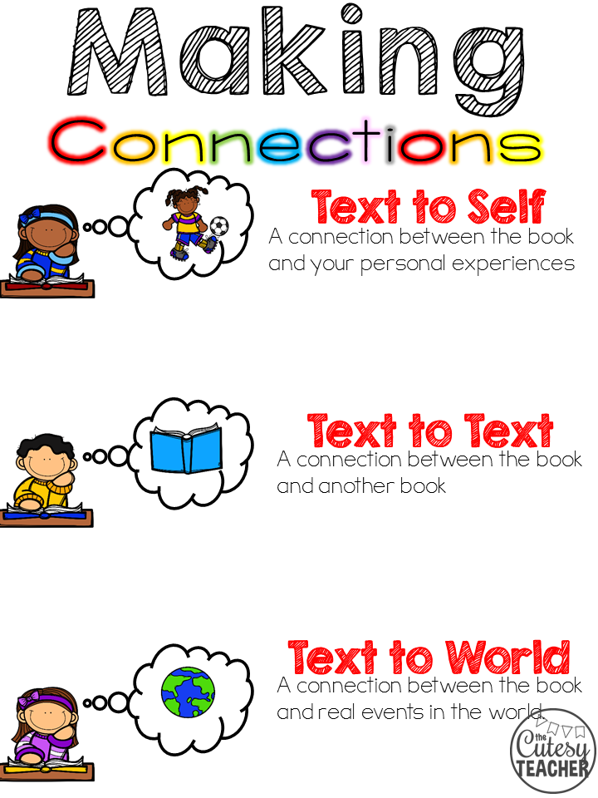  Guided Group | Learning Intention  We are learning to bring our background knowledge to understand fiction texts  Success Criteria  I will be successful if I can  Make 2 connections to the text (text to self  Bring 2 pieces of my knowledge of the world to the text  Teaching Sequence  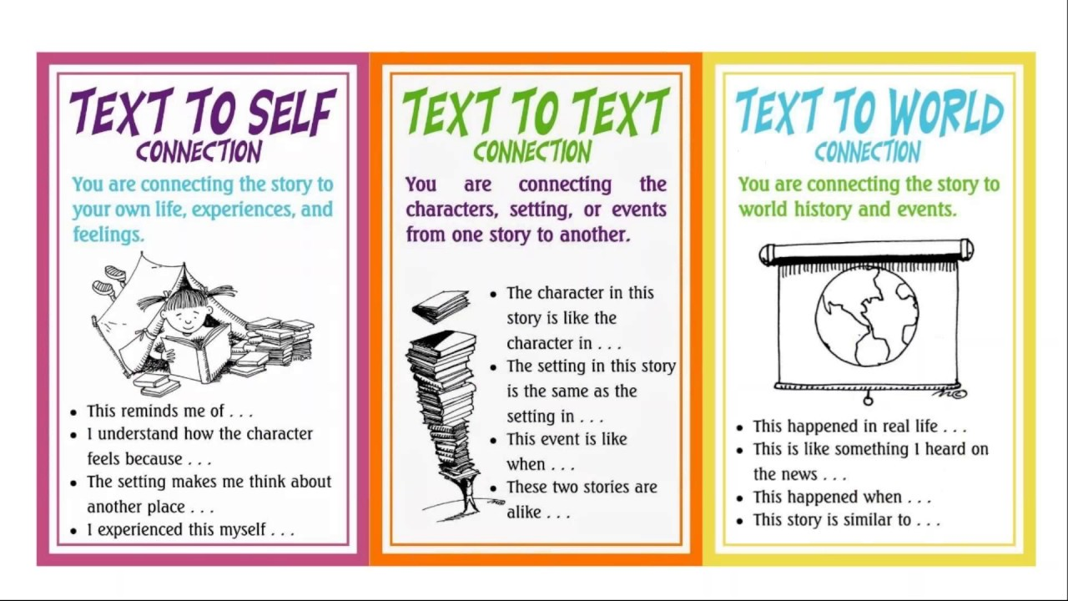  Guided Group | Learning Intention  We are learning to Infer the big idea or theme of a text and discuss how they are applicable to people’s lives today  Success Criteria  Teaching Sequence  Guided Group | Learning Intention  We are learning to use base words to predict/infer the meaning of words.  Success Criteria  I will be successful if I can:  Identify 3 base words in fiction texts and predict their meanings  Teaching Sequence  Guided Group | Learning Intention  We are learning to identify the authors voice in fiction  Success Criteria  I will be successful if I can  - Define what an adverb is  - Learn to identify and list adverbs in texts  - Use the adverbs in texts to create different sentences.  Teaching Sequence  Guided Group | Learning Intention  Identify words with multiple meanings within text students read.  Success Criteria  Teaching Sequence  Guided Group

